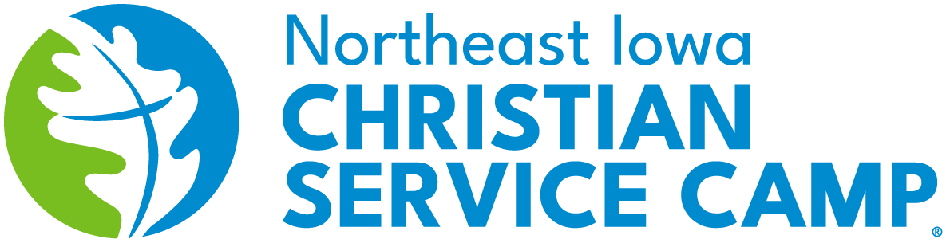
Newsletter
Fall - 2026

Greetings Church…
It has been an exciting summer season here at NEICSC…
- First, was our regular camp programming:
  - Junior High # 1 – June 14-19 = 40 campers & 14 faculty
  - 3rd-5th Grade – June 21-24 = 42 campers & 16 faculty
  - Overnight – June 26-27 = 18 campers w/guardians & 5 faculty
  - Highschool – June 28-July 3 = 75 campers & 16 faculty
  - Junior High # 2 – July 19-24 = 42 campers & 14 faculty
  - Young Adult Weekend – July 31-August 2 = 12 campers & 9 faculty
  - Last Chance Camp – August 14-16 = 13 campers & 12 faculty

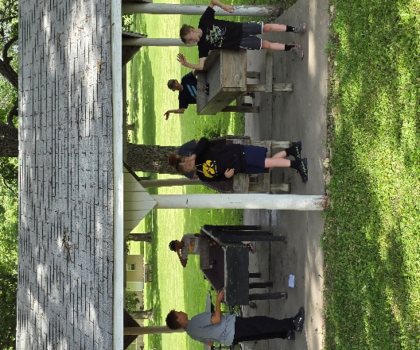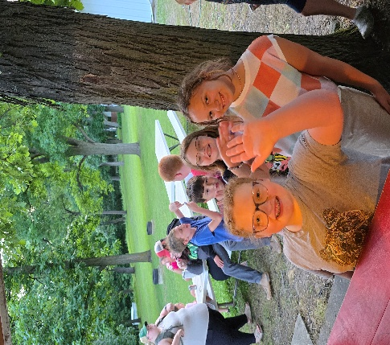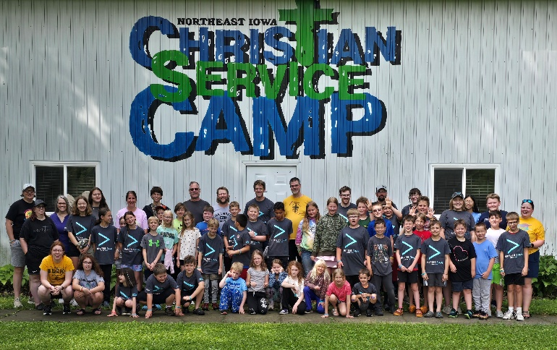

- Second, we had several groups choose to host their retreats here:
  - May 21-24 – Simply Christ Ministry = 120 participants
  - July 7-11 – American Zotung Church Association (AZCA) = 220 participants
  - July 16-18 – KCBA Women’s Retreat = 110 participants
  - July 26-30 – Good News Church Retreat = 90 participants
  - August 21-23 – KCRC Retreat = 130 participants
  - September 6-8 – Webster City Church Retreat = 50 participants
  - September 11-13 – Celebrate Recovery Weekend = 150 participants
  - There were a handful of other retreat groups that utilized our facilities too.

What a blessing it is to have these wonderful facilities to use for God’s glory
and the faith growth of those who come to spend time here.
- Thirdly, the new house w/basement is coming along nicely. (Some pics below)
  - Thanks to all of you for your support and contributions to the house project.

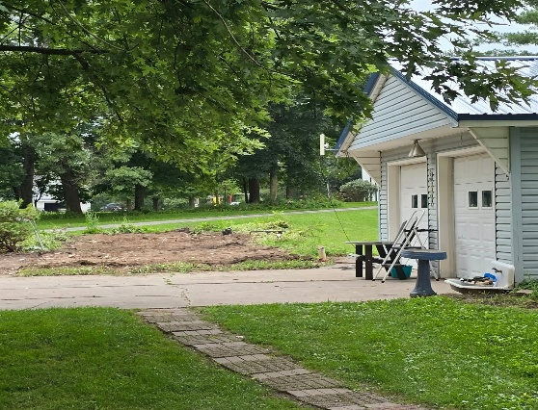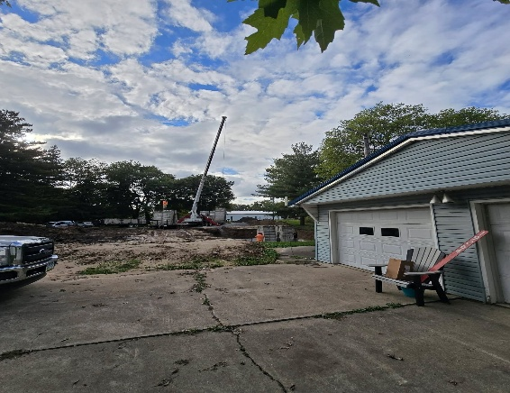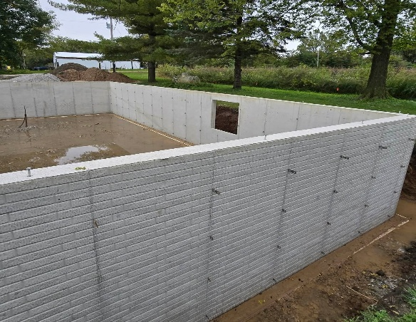

- We had our first NEICSC Preacher’s Golf Outing in Clarksville, IA on September 28.
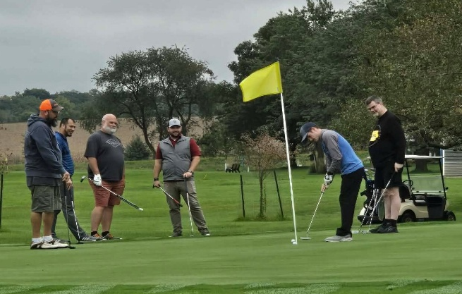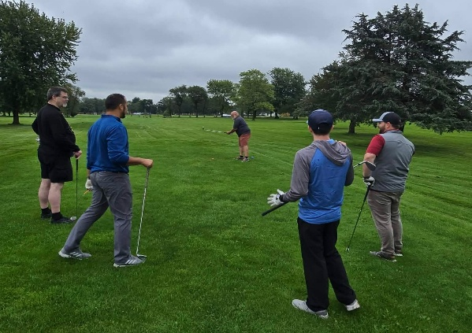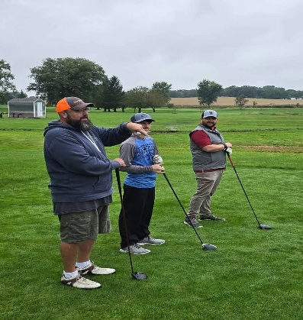

- Introducing a new opportunity for church youth groups to come to NEICSC in order to Camp-n-Serve. A fun evening with games, pizza, devotions, & campfire, followed by a morning service project. Contact Warren if interested in scheduling a stay.
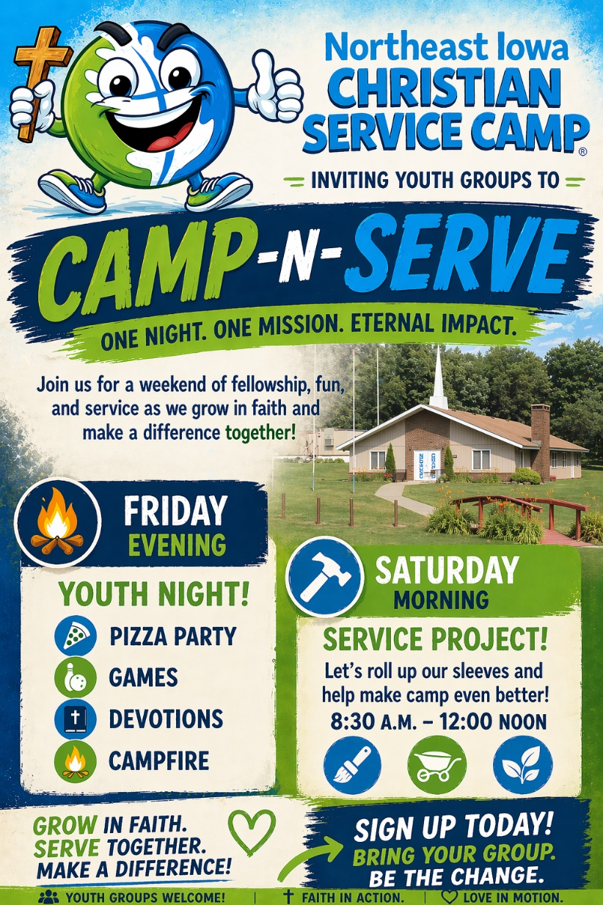

Please continue to keep Northeast Iowa Christian Service Camp in your prayers.
We continue to pray for and dream about ideas for the future.


In HIS Service,

Warren E. Curry

